**East West University**

**Department of CSE**

**Group Project**

| **Course Code and Name:CSE251**  **Electrical Circuits** | | |
| --- | --- | --- |
| **Project Report** | | |
| **Project name**  Design of a Triangular wave generator using Operational Amplifier for a specified input. | | |
| **Semester :Fall 2021** | | **Group number:01** |
| **Name of student:**   1. Md.Abu Zafor   2.khandaker Mushayed Rahman  3.Saikat Sudipta Shuva  **Student Id:**  1.2020-2-60-158  2.2020-2-60-125  3.2020-2-60-167 | **Submitted to:**  **S. M. Raiyan Chowdhury**  **Lecturer** **Department of Electronics and Communications Engineering** | |

**Problem Statement:**

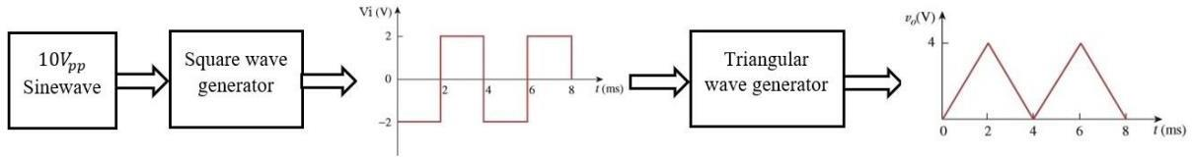

**Figure:01**

Fig.1 shows a design process of a Triangular wave generator circuit. The design process includes two design segments (a square wave generator & a triangular wave generator) to get the final output (V). Use a 10Vpp sinusoid as input and operational amplifiers to design. Design the circuit components and finally simulate to test the circuit. [ Note that, for design purpose, the values of the resistors should not exceed more than 10kΩ.]

**Design Detail:**

1.Resistor (2k. 5k, 10k)

2.DC voltage source (VDC) (10V)

3.Sinusoidal Voltage Source (VSIN)

4.Op amp (uA741)

5.Ground (GND_EARTH)

6.Capacitor (c) (0.318uF)

**Sine to Square Wave Generator**

1.At first we took a non-inverting op amp with 10V DC source in 7th and 4th terminal

2.Connect sinusoidal source in inverting terminal. In sinusoidal source, will add 5V in amplifier and 250Hz.

3. Connect three resistors (2k,5k,10k) along with the op amp.

4.This op amp will turn sinusoidal wave into square wave. As there will be 10V DC supply on 7th and 4th terminal, the square output will be approximately 4.89V.

**Square to Triangular Wave Generator**

1.The output of first op amp will be connected to second op amp’s inverting terminal along with a 5k resistor.

2.There will be a capacitor of 0.318uF value connected to input and output terminal.

3.There will be 10V DC voltage source connected to the 7th and 4th terminal.

4.At last the non-inverting terminal will be grounded. This op amp will generate square wave to triangle wave. It will show the output of 4.89V approximately.

**Abstract:**A Triangular Wave Generator Using Op amp can be formed by simply connecting an integrator to the square wave generator. Triangular wave is generated by alternatively charging and discharging a capacitor with a constant current. This is achieved by connecting integrator circuit at the output of square wave generator. The frequency of the triangular wave is same as that of square wave. Although the amplitude of the square wave is constant, (± Vsat), the amplitude of the triangular wave decreases with an increase in its frequency, and vice versa. This is because the reactance of capacitor decreases at high frequencies and increases at low frequencies. In this project, we have seen that, the output of integrator is a Triangular Wave Generator Using Op amp when the input is a square wave. This means, that a Triangular Wave Generator Using Op amp can be formed by simply connecting an integrator to the square wave generator.

**Circuit Diagram:**

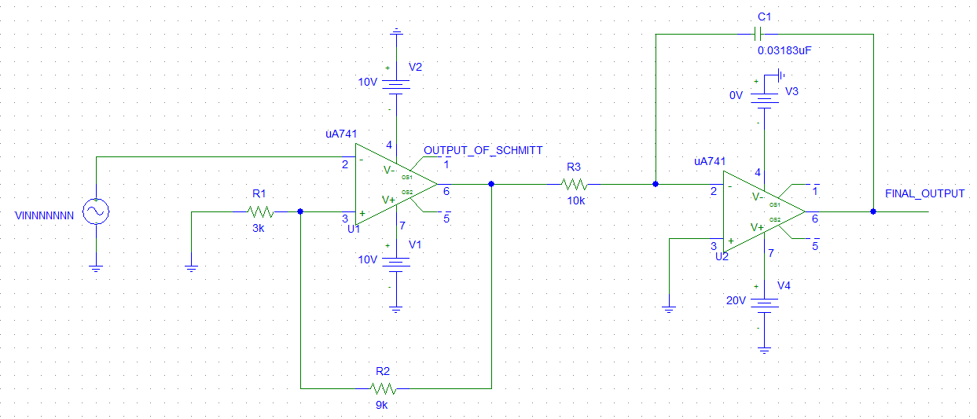  **Figure :02**

**Simulation Result:**

**First Result:**

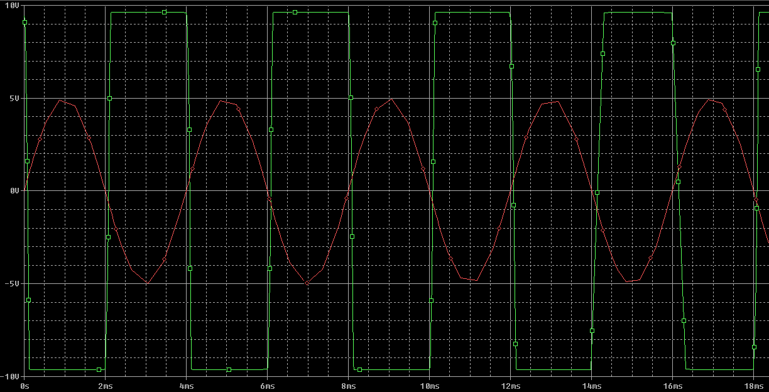

**Figure:** Sine to square wave

**Second Result:**

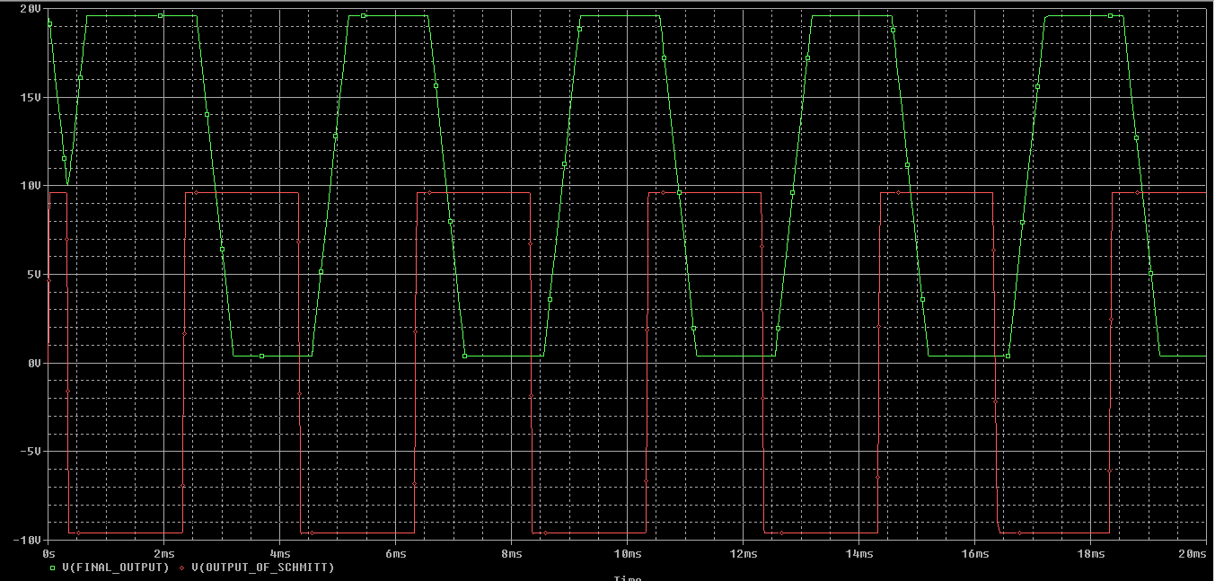

**Figure:** Square to triangular wave

**Third Result:**

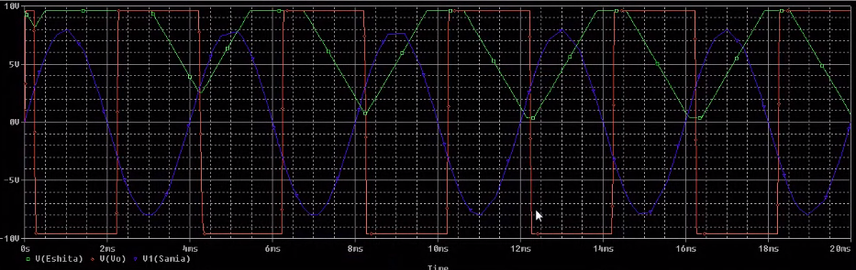

**Figure:** Sine square and triangular wave

**Demonstration:**

First of all, we took a non-inverting op amp. On the positive terminal we applied sinusoidal source. When we applied 5V and 250Hz on sinusoidal source and 10V DC source on the 4th and 7th terminal. The output will be in the positive saturation until the input of non-inverting terminal is bigger than inverting terminal. As the same way, the output will be in negative saturation until the input of positive terminal of negative terminal. As it is, we got a square wave of 4.89V as our output was 5V.

This output is directly connected to second op amp’s inverting terminal. So is the input for the second op amp. And there is a capacitor connected to input and the output terminal. In the second op amp the wave will be triangular of 4.89V.

From this project, we have learned how to generate a square waveform from a sine input and generate a triangular waveform from square input using operational amplifier. We have gained more knowledge about Schmitt Trigger circuit and Integrator circuit while preparing this project.